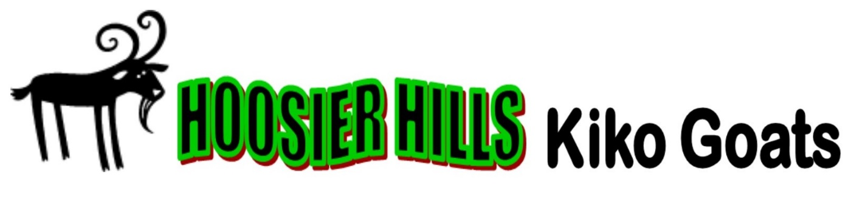
Hoosier Hills Performance Test Accomplishments:

2023 MississippiTest: Earned #1 Top Consigner award with #1 overall ranked buck. He also ranked #1 in ribeye area, #4 in fecal egg count, and #4 in average daily gain. We also had the #4 overall buck who was the fecal egg count champion and # 6 adg.out of a field of 200 bucks. Bucks sired by BWP Wild Billy, WEB Hoosier Hammer
2022 West Virginia Test: Earned #1 Top Consigner award with #9,15,20,28,31&38 overall ranked bucks out of a field of 200 bucks. Included the #3 ranked Ribeye area buck as well as #1,6,10,18&26 ranked FEC bucks. Bucks sired by BWP Wild Billy, WEB Blues Dominator and Hoosier Survivor
2021 Eastern Oklahoma test: Reserve Champion ADG with a tie for 1st place. Buck sired by TBR Resistol out of a Dominator daughter
2021 West Virginia Test: Earned #2 Top Consigner award with #7,9,16,20,22&31 overall ranked bucks out of a field of 170 bucks. Included the #2 ADG ranked buck as well as #7,13,16,19 ranked FEC bucks. Bucks sired by PBG Hoosier Ten High, WEB Hoosier Hammer and Hoosier Survivor
2020 West Virginia Test: Earned #3 Top Consigner award with #11,19,20&21 overall bucks, and #2,7&8 ribeye area bucks. All bucks with better than average fecal egg counts. Bucks sired by WEB Dominator and Hoosier Hammer
2019 Eastern Oklahoma Test: Earned Top Consigner Reserve Champion award with the #3 and #6 overall bucks, sired by WEB Makers Mark and PBG Hoosier Ten High
2018 West Virginia Test: #4 Overall Buck (out of 127 bucks on test) sired by PBG Indiana Jones
2017 Eastern Oklahoma test: Reserve Grand Champion Low fecal egg count sired by Len 8
2016 Western Maryland Test: Top ten overall buck “PBG Hoosier Ten High” and 5th ranked buck carcass contest sired by WEB Jackhammer
2015 Western Maryland Test: Top ranked Famacha score buck (always a 1) and 3 bucks with larger than average ribeye area, one was 36% larger sired by WEB Jackhammer and PBG Prince
2014 Western Maryland Test: #8 ranked buck for low fecal egg count. Top buck for ribeye area ratio, with a ratio of 145% sired by PBG Shoguns Oz

